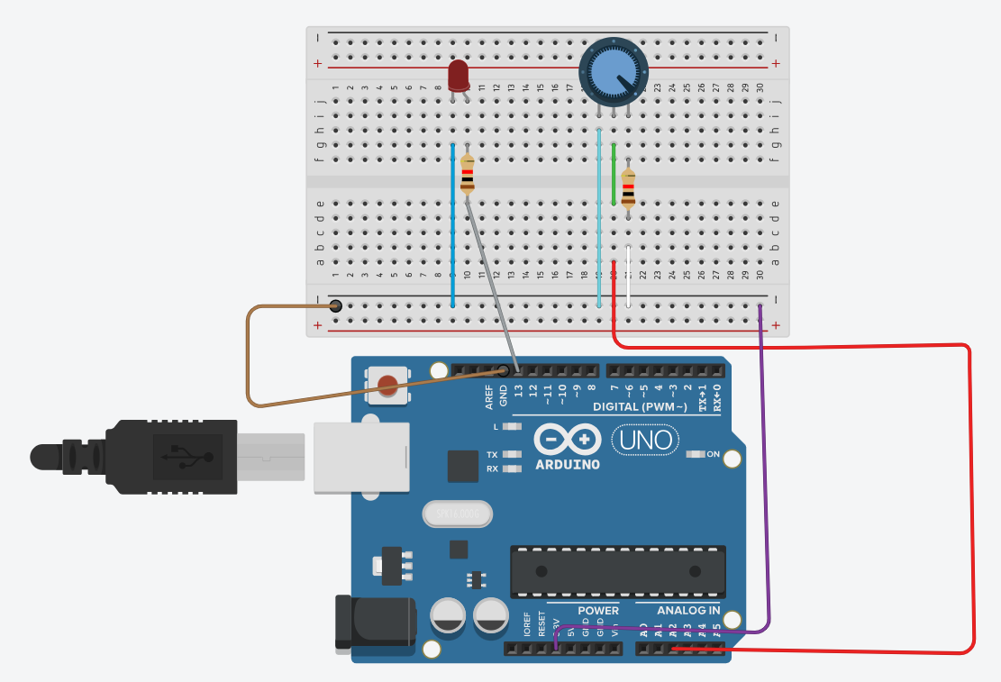

int potentiometer = A2;
int ledPin = 13;
void setup()
{
pinMode(ledPin, OUTPUT);
Serial.begin(9600);
}
void loop()
{
digitalWrite(LED_BUILTIN, HIGH);
delay(1000); // Wait for 1000 millisecond(s)
digitalWrite(LED_BUILTIN, LOW);
delay(1000); // Wait for 1000 millisecond(s)
}

